Lab 8 – My Solutions
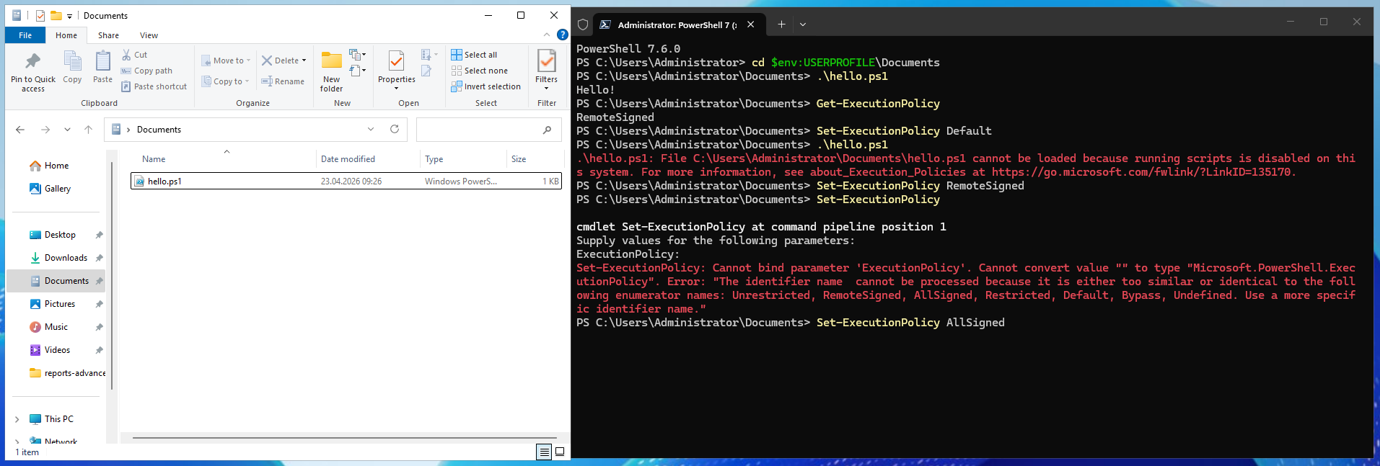
3.1: Running a Script, Execution Policy:

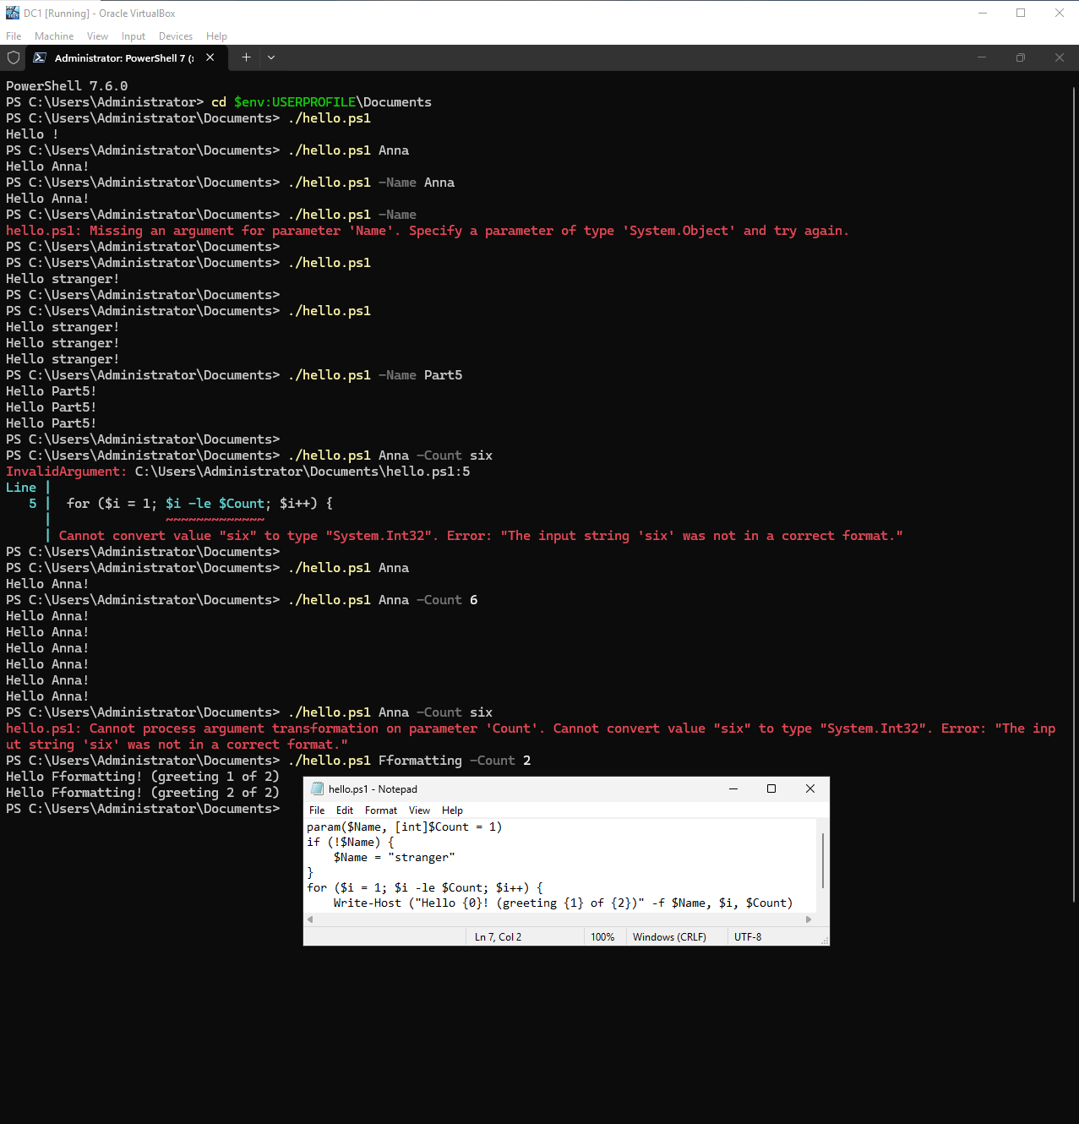
3.2: Using Variables, Loops, and Conditional Statements:
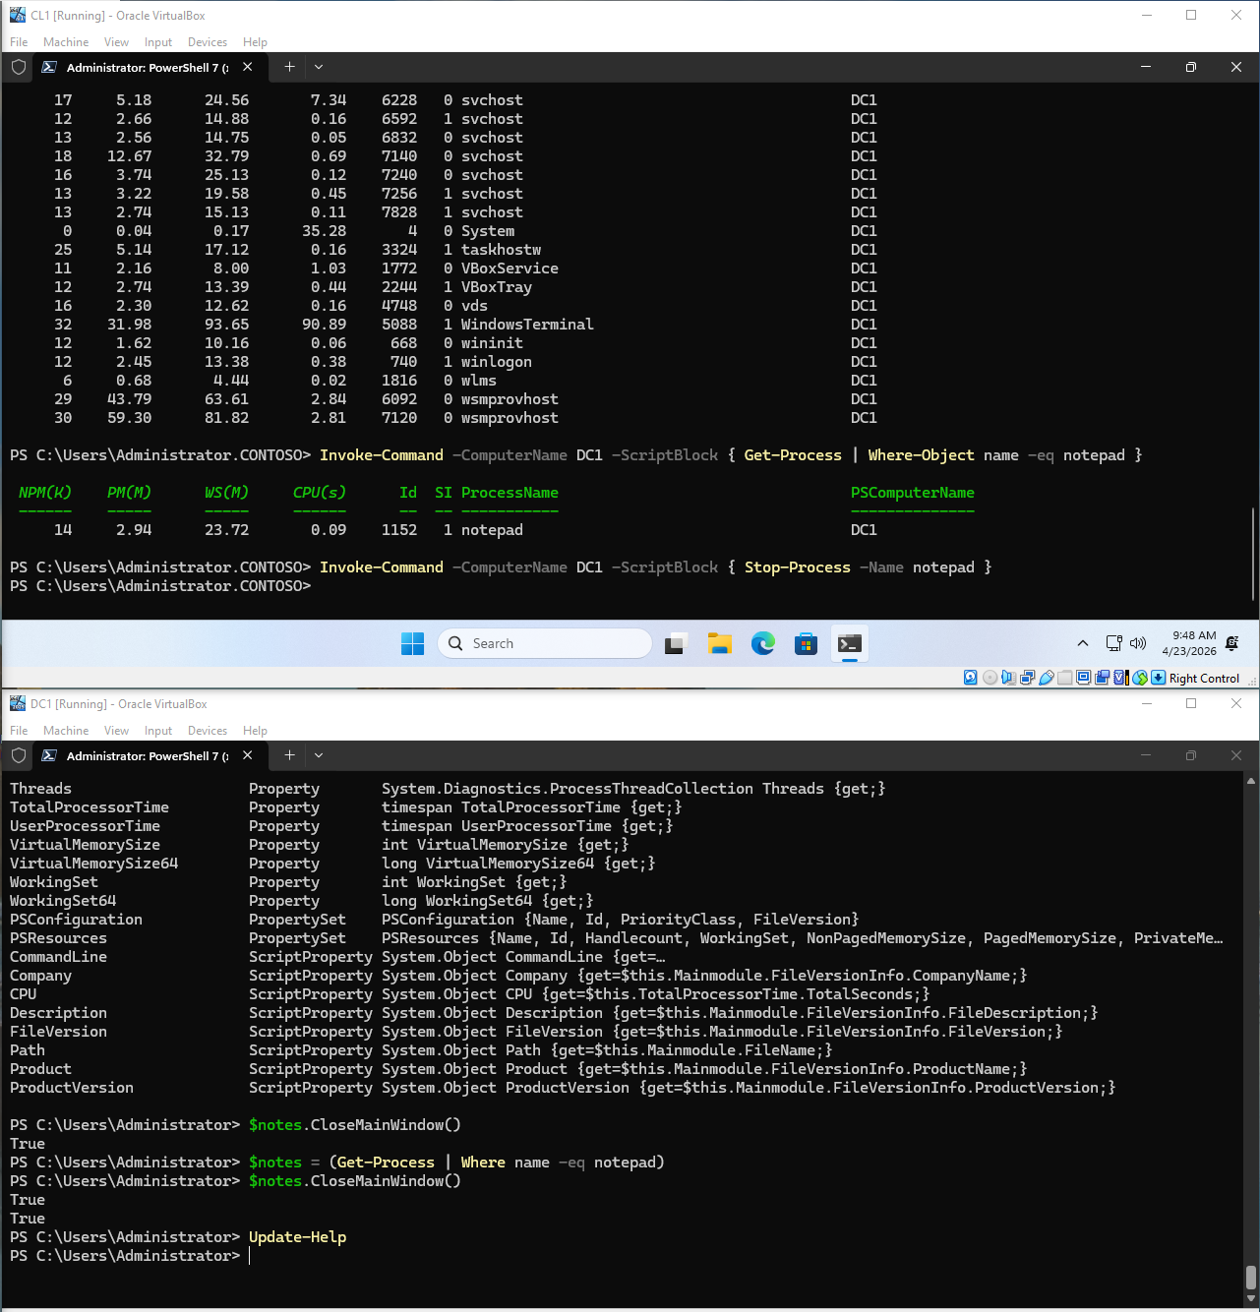
3.3: Communication with the System
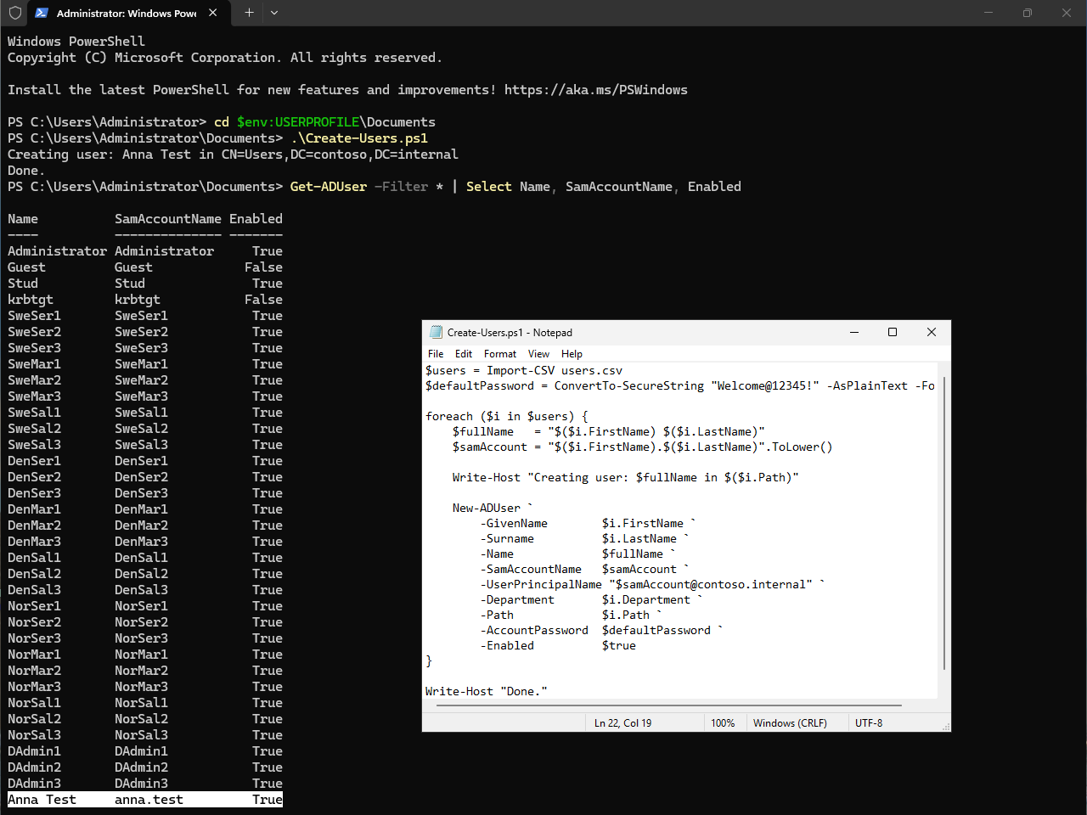
3.4: Sharing Folders via PowerShell

